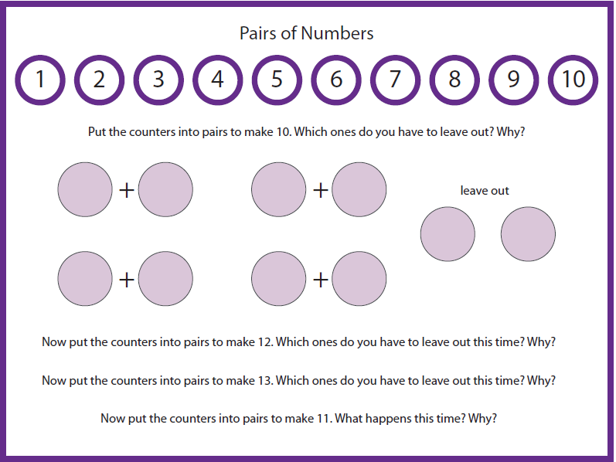
http://nrich.maths.org/7233
© University of Cambridge

